BIS LAB – 1WN24CS141

LAB 1: GENETIC ALGORITHM - FRACTIONAL KNAPSACK
import random
ITEMS = [(60, 10), (100, 20), (120, 30)]
CAPACITY = 50
pop = [[random.random() for _ in ITEMS] for _ in range(100)]
def fitness(ind):
w = sum(f * item[1] for f, item in zip(ind, ITEMS))
v = sum(f * item[0] for f, item in zip(ind, ITEMS))
return v if w &lt;= CAPACITY else 0

for g in range(1, 10):
pop.sort(key=fitness, reverse=True)
best_v = fitness(pop[0])
print(f&quot;Gen {g:2d} | Best Fractions: {[round(f, 2) for f in pop[0]]} | Value: {best_v:.1f}&quot;)
if best_v &gt;= 240: break

pool = pop[:30]
pop = pop[:5] + [
[
random.random() if random.random() &lt; 0.1
else random.choice([p1_gene, p2_gene])
for p1_gene, p2_gene in zip(random.choice(pool), random.choice(pool))
]
for _ in range(15)
]
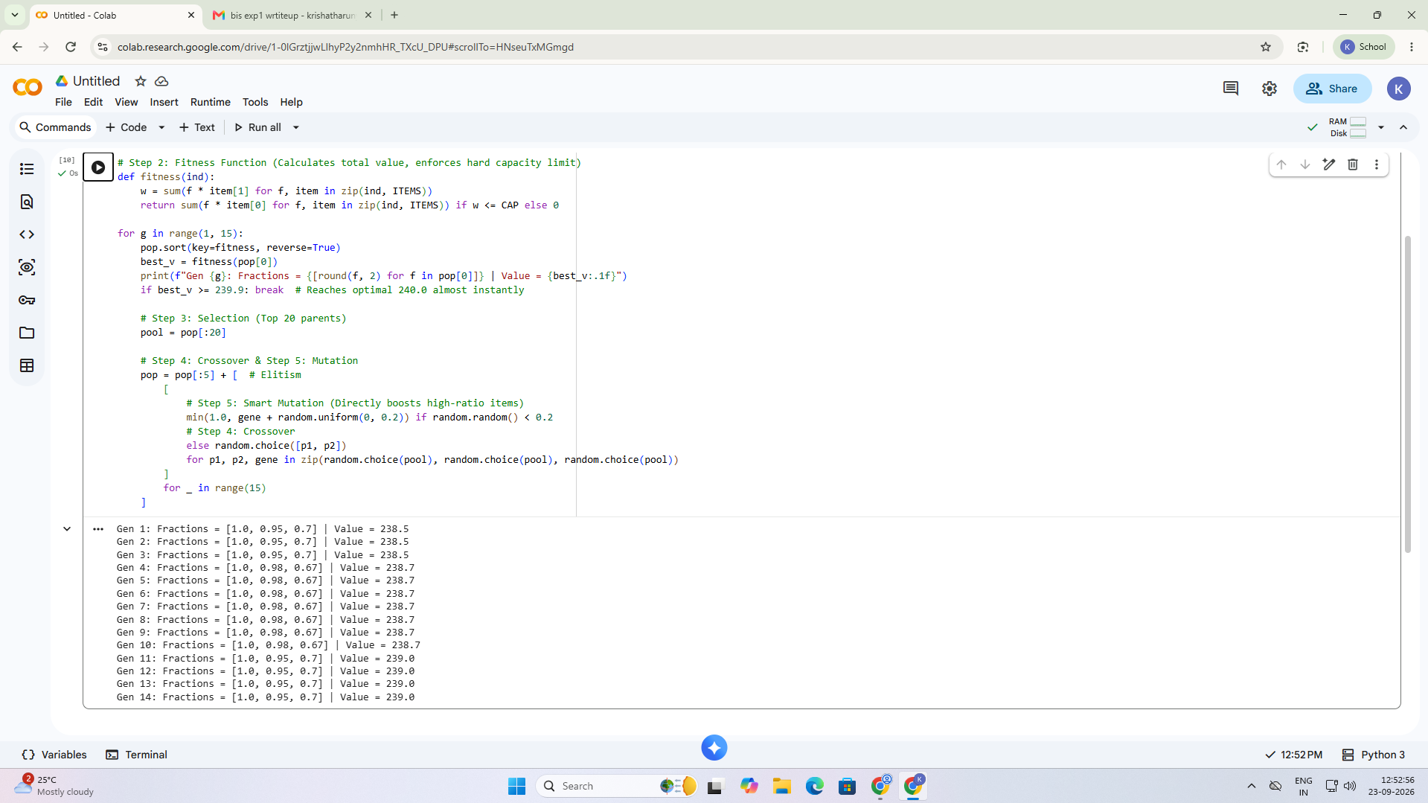

LAB 2: PARTICLE SWARM OPTIMIZATION - TSP
import random, math
cities = [(0,0), (2,3), (5,2), (6,6), (1,5)]
def distance(route):
d = 0
for i in range(5):
d += math.dist(cities[route[i]], cities[route[(i+1)%5]])
return d
particles = [random.sample(range(5), 5) for _ in range(5)]
best = min(particles, key=distance)
for _ in range(50):
for p in particles:
new = p.copy()
a, b = random.sample(range(5), 2)
new[a], new[b] = new[b], new[a]
if distance(new) &lt; distance(p):
p[:] = new
if distance(p) &lt; distance(best):
best = p.copy()
print(&quot;Best Route:&quot;, best)
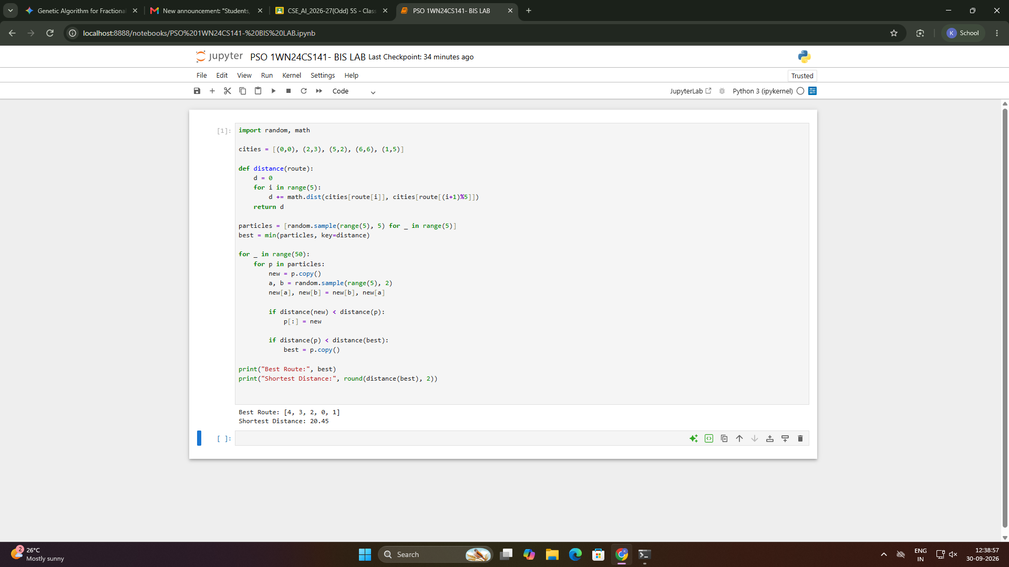
print(&quot;Shortest Distance:&quot;, round(distance(best), 2))

LAB 3: OPTIMIZATION VIA GENE EXPRESSION – ROUTE OPTIMIZATION
import random
cities = [0, 1, 2, 3]
distance = [
[0, 10, 15, 20],
[10, 0, 35, 25],
[15, 35, 0, 30],
[20, 25, 30, 0]]
def fitness(route):
total = 0
for i in range(len(route) - 1):
total += distance[route[i]][route[i+1]]
return total
best = None
best_distance = 9999
for _ in range(100):
route = random.sample(cities, len(cities))
d = fitness(route)
if d < best_distance:
best = route
best_distance = d
print("Best Route:", best)
print("Distance:", best_distance)
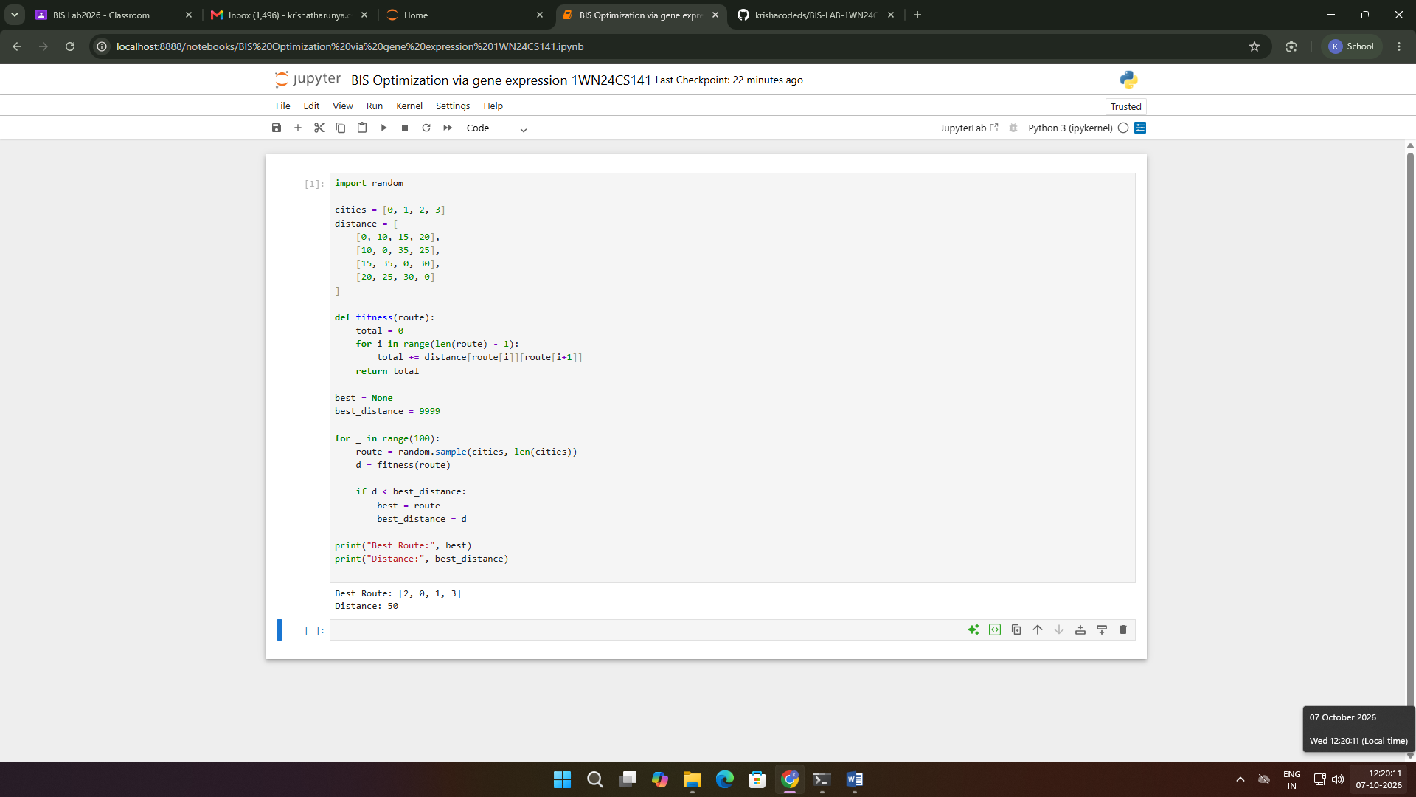
LAB 4: ANT COLONY OPTIMIZATION - TSP

import random

d = [[0, 2, 3],
[2, 0, 4],
[3, 4, 0]]

n = len(d)
p = [[1]*n for _ in range(n)]
best, cost = None, float('inf')

for _ in range(20):
path = [random.randrange(n)]
while len(path) < n:
c = [i for i in range(n) if i not in path]
path.append(max(c, key=lambda x: p[path[-1]][x]/d[path[-1]][x]))

total = sum(d[path[i]][path[(i+1)%n]] for i in range(n))
if total < cost:
best, cost = path[:], total
for i in range(n):
a, b = path[i], path[(i+1)%n]
p[a][b] += 1/total

print("Path:", best + [best[0]])
print("Cost:", cost)

